

**VBA MACRO TOOL:**

URL Shortener



# Revision History Page

|  |  |  |  |
| --- | --- | --- | --- |
| **Date** | **Version** | **Description** | **Author/s** |
| 10/08/2019 | 1.0 | Initial creation | Ron Arbiel S. Tumandao |

# Description

This VBA macro tool was designed to shorten the length of any URL or websites, and it can also check if the URL is valid or not. The shortened URL is applicable only for sending messages or emails and cannot be open directly from the address bar or URL bar of a web browser since it is not using any API or web server.

# Platform Used

Microsoft Excel 2016

# Prerequisites:

1. Copy and paste the shortcut icon “URL shortener” to your preferred location example Desktop.
2. To execute this program, you must double click the shortcut icon “URL shortener”.

## Visual Basic for Application

|  |  |  |
| --- | --- | --- |
| **Variables of Workbook_Open()** | **Type** | **Description** |
| rg | Range | Range of a current region starting from “A1” to last used range. |
| strPath | String | Path of URL Shortener Report folder on Desktop |
| LastRowIndex | Integer | Last Row of used range in an active sheet |
| RowIndex | Integer | Starting and next number for For Loops |
| UsedRng | Range | Used ranged in an active sheet |

|  |  |  |
| --- | --- | --- |
| **Variables of Paste_Click()** | **Type** | **Description** |
| strClipboard | String | URL String from clipboard or textbox |
| strLink | String | First/Second string of URL excluding http:// or https:// and dot as delimiter. |
| strFirst | String | First 3 characters of First/Second string of URL excluding http:// or https://. |
| strSecond | String | First 3 characters of First/Second string of URL excluding http:// or https:// starting from 5th character. |
| strThird | String | Last 2 characters of First/Second string of URL excluding http:// or https:// |
| strRandom | String | 8 alphanumeric random characters |
| tmpCSV | String | Excel data to be printed to CSV file |
| CSVFile | String | Path of “List of short URL.csv” file |
| f | Integer | File number |
| LastRowIndex | Integer | Last Row of used range in an active sheet |
| RowIndex | Integer | Starting and next number for For Loops |
| UsedRng | Range | Used ranged in an active sheet |
| rg | Range | Range of a current region starting from “A1” to last used range. |
| objData | DataObject | Data Object to get string from clipboard |
| URLlogExist | Collection | Check if URL is already in the list (List of short URL.csv) |

|  |  |  |
| --- | --- | --- |
| **OrigLink_MouseDown()** | **Type** | **Description** |
| strClipboard | String | URL String from clipboard or textbox |
| LastRow | Integer | Last row in active sheet |

|  |  |  |
| --- | --- | --- |
| **Functions** | **Type** | **Description** |
| AppendExcelDataToCSVfile() | String | It will append excel data(URL) to CSV file (List of short URL.csv). |
| URLisValid() | Boolean | It will validate the entered URL if valid it will return true and if not will return false. |
| RandomizeF() | String | It will return 8 random alphanumeric strings and it’s dynamic. |
| getFirstStr() | String | It will return first string of a URL and dot as a delimiter. |
| getSecondStr() | String | It will return second string of a URL and dot as a delimiter. |
| getDomainPath() | String | It will return third string of URL and / as a delimeter. |
| getProfileName | String | It will return third string of computer userprofile and \ as a delimeter. |
| CountCharacter() | Integer | It will count the number of specific characters in the URL. |
| CheckURLinCSV | Collection | It will check if URL is already in the CSV file (List of short URL.csv). |

1. **Double click the shortcut icon to start (“URL Shortener”) .**
2. 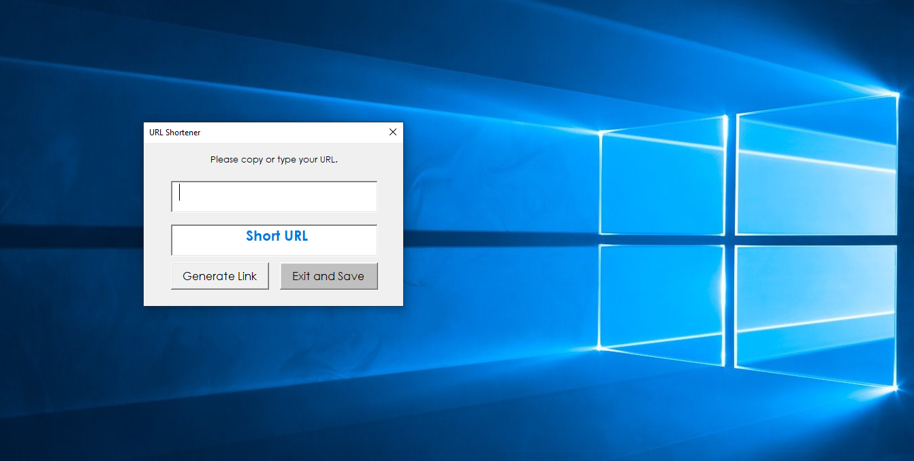**Type a URL on the textbox or just simply copy a URL and click Generate Link button to paste it on the textbox.**
3. 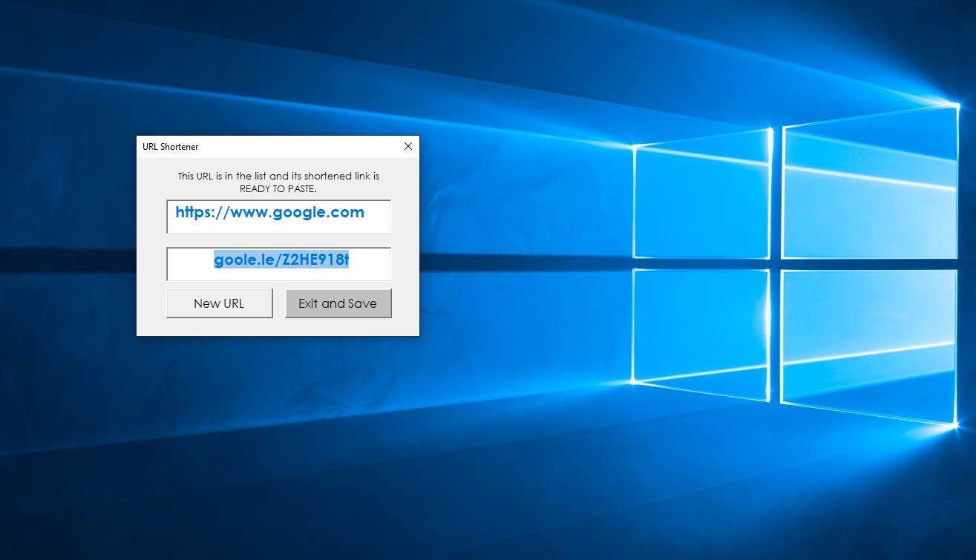**Once you clicked the Generate Link button, it will generate a ready to paste shortened link.**
4. **To edit your URL just simply click the URL textbox.**

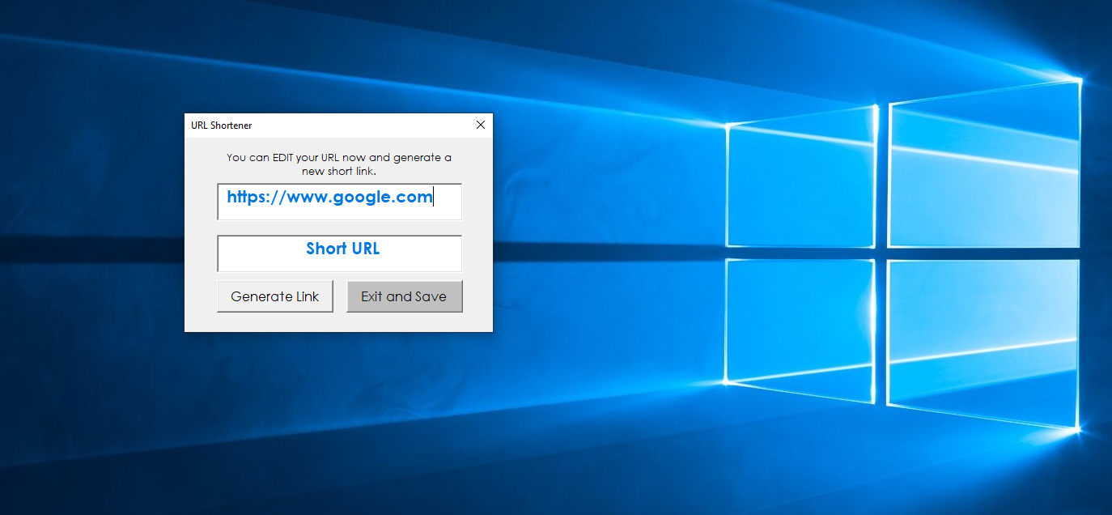

1. 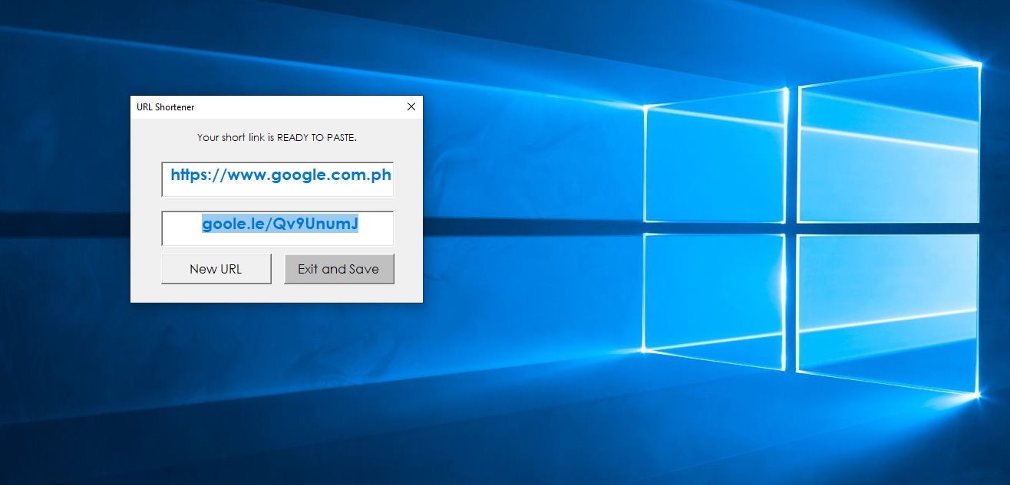**To add a new URL just simply click the New URL button.**
2. **To exit the program just click the Exit and Save button.**

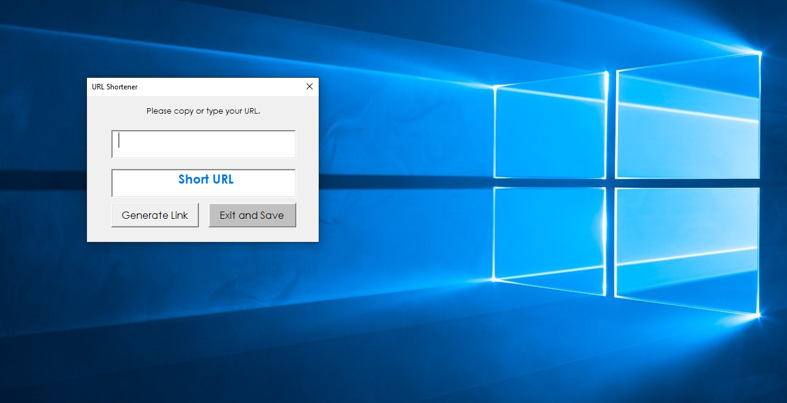

# Error Handling

User error handling:

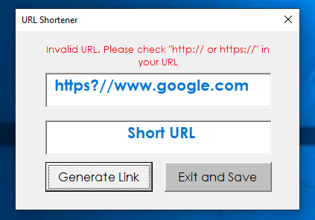

# Calibration Guide

This reusable bot has two macro versions: (1) ***URL Shortener.xlsm*** – this version is using vbModal property, it means the user must close or hide the UserForm before anything else in the application can occur. In other words, you can’t click cells in Excel and macros will not run until the user hides or closes the UserForm. (2) ***URL Shortener v2.xlsm*** – this version is using vbModeless property, it means the user can still fully interact with the rest of the application. You can click cells in Excel. You can copy and paste ranges. You can do anything you normally could do in Excel. In addition to that, your macros will continue to run and you can even launch new macros. You’re not forced to close or hide your UserForm before running other macros. Since this bot will autogenerate a folder and CSV file on the desktop as part of the process, the user can still delete or remove them from the desktop but not allowed to edit or change the contents since it is a log file used for checking all URLs with generated shortened links. Also, it is not allowed to change the excel file name of both macro versions.